**Practical No.1**

**Aim: Encrypting and Decrypting Data Using OpenSSL.**

**Encrypting Messages with OpenSSL**

OpenSSL can be used as a standalone tool for encryption. While many encryption algorithms can be used, this lab focuses on AES. To use AES to encrypt a text file directly from the command line using OpenSSL, follow the steps below:

**Step 1: Encrypting a Text File**

a. Log into CyberOPS Workstation VM.

b. Open a terminal window.

c. Because the text file to be encrypted is in the /home/analyst/lab.support.files/ directory, change to that directory:

**[analyst@secOps ~]$ cd ./lab.support.files/**

**[analyst@secOps lab.support.files]$**

d.Type the command below to list the contents of the encrypted letter_to_grandma.txt text file on the screen:

**[analyst@secOps lab.support.files]$ cat letter_to_grandma.txt**

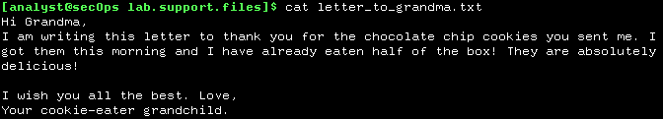

e. From the same terminal window, issue the command below to encrypt the text file. The command will use AES-256 to encrypt the text file and save the encrypted version as message.enc. OpenSSL will ask for a password and for password confirmation. Provide the password as requested and be sure to remember the password.

**[analyst@secOps lab.support.files]$ openssl aes-256-cbc -in letter_to_grandma.txt -out message.enc**

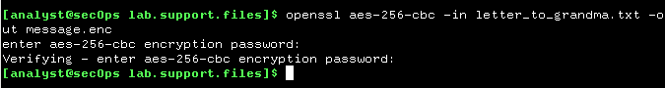

f. **cat message.enc**

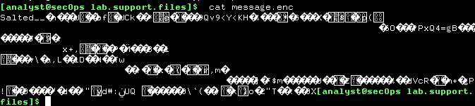

g. To make the file readable, run the OpenSSL command again, but this time add the -a option. The -a option tells OpenSSL to encode the encrypted message using a different encoding method of Base64 before storing the results in a file.

**[analyst@secOps lab.support.files]$ openssl aes-256-cbc -a -in letter_to_grandma.txt -out message.enc**

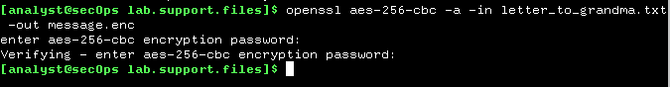

h. **cat message.enc**

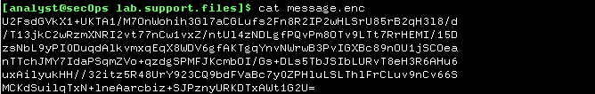

**Step2: Decrypting Messages with OpenSSL**

With a similar OpenSSL command, it is possible to decrypt message.enc.

a. Use the command below to decrypt message.enc:

**[analyst@secOps lab.support.files]$ openssl aes-256-cbc –d -a -in message.enc -out decrypted_letter.txt**



b. OpenSSL will ask for the password used to encrypt the file. Enter the same password again.

c. When OpenSSL finishes decrypting the message.enc file, it saves the decrypted message in a text file called decrypted_letter.txt. Use the cat display the contents of decrypted_letter.txt:

**[analyst@secOps lab.support.files]$ cat decrypted_letter.txt**

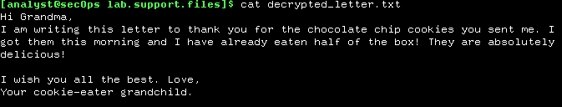

**Practical No.2**

**Aim: Demonstrate the use of Snort and Firewall Rules.**

**Part 1: Preparing the Virtual Environment**

a. Launch Oracle VirtualBox and change the CyberOps Workstation for Bridged mode

b.Launch the CyberOps Workstation VM, open a terminal and configure its network by executing the sh script.

**[analyst@secOps ~]$** sudo ./lab.support.files/scripts/configure_as_dhcp.sh

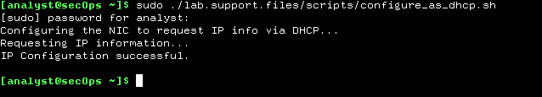

c. Use the **ifconfig** command to verify CyberOps Workstation VM now has an IP address on your local network. You can also test connectivity to a public webserver by pinging www.cisco.com. Use Ctrl+C to stop the pings.

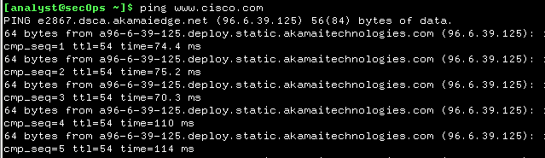

**Part 2: Firewall and IDS Logs**

Step 1: Real-Time IDS Log Monitoring

1. From the CyberOps Workstation VM, run the script to start mininet.

**[analyst@secOps ~]$ sudo ./lab.support.files/scripts/cyberops_extended_topo_no_fw.py**

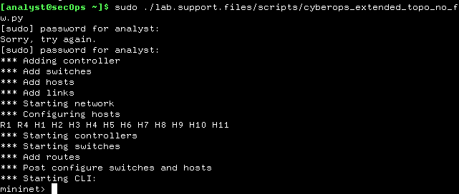

1. From the mininet prompt, open a shell on R1 using the command below:

**mininet> xterm R1**



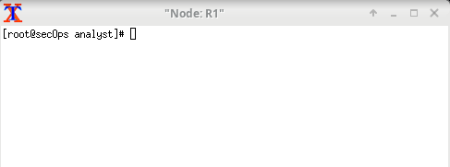

c. From R1’s shell, start the Linux-based IDS, Snort.

**[root@secOps analyst]# ./lab.support.files/scripts/start_snort.sh**

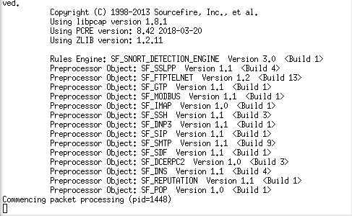

d. From the CyberOps Workstation VM mininet prompt, open shells for hosts H5 and H10.

**mininet> xterm H5**



**mininet> xterm H10**

e. H10 will simulate a server on the Internet that is hosting malware. On H10, run the mal_server_start.sh script to start the server.

**[root@secOps analyst]# ./lab.support.files/scripts/mal_server_start.sh**



e. H10 will simulate a server on the Internet that is hosting malware. On H10, run the mal_server_start.sh script to start the server.

f. On H10, use netstat with the -tunpa options to verify that the web server is running. When used as shown below, netstat lists all ports currently assigned to services:

**[root@secOps analyst]# netstat -tunpa**

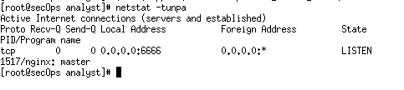

g. In the R1 terminal window, an instance of Snort is running. To enter more commands on R1, open another R1 terminal by entering the xterm R1 again in the CyberOps Workstation VM terminal window. You may also want to arrange the terminal windows so that you can see and interact with each device.

h. In the new R1 terminal tab, run the tail command with the -f option to monitor the /var/log/snort/alert file in real-time. This file is where snort is configured to record alerts.

**[root@sec0ps analyst]# tail -f /var/log/snort/alert**

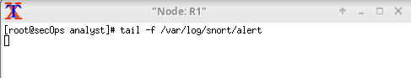

1. From H5, use the wget command to download a file named Nimda.Amm.exe. Designed to download content via HTTP, wget is a great tool for downloading files from web servers directly from the command line.

**[root@secOps analyst]# wget 209.165.202.133:6666/W32.Nimda.Amm.exe**

**Or**

**curl -O 209.165.202.133:6666/W32.Nimda.Amm.exe**

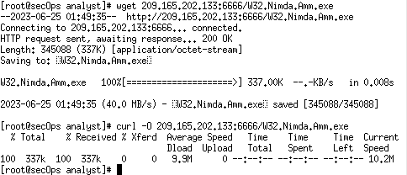

j. As the malicious file was transiting R1, the IDS, Snort, was able to inspect its payload. The payload matched at least one of the signatures configured in Snort and triggered an alert on the second R1 terminal window (the tab where tail -f is running). The alert entry is show below. Your timestamp will be different:



On H5, use the tcpdump command to capture the event anddownload the

malware file again so you can capture the transaction.type command.

**“tcpdump –i H5-eth0 –w nimda.download.pcap&”**

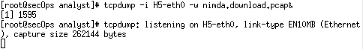

Press ENTER a few times to regain control of the shell while tcpdump runs in

background.

Now that tcpdump is capturing packets, download the malware again. On H5, re-run

the command.

**“curl -O 209.165.202.133:6666/W32.Nimda.Amm.exe”**



m. Stop the capture by bringing tcpdump to foreground with the fg Because tcpdump was the only process sent to background, there is no need to specify the PID. Stop the tcpdump process with Ctrl+C. The tcpdump process stops and displays a summary of the capture. The number of packets may be different for your capture.

**[root@secOps analyst]# fg tcpdump -i h5-eth0 -w nimda.download.pcap**

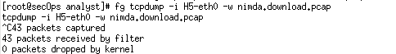

n. On H5, Use the ls command to verify the pcap file was in fact saved to disk and has size greater than zero:

**[root@secOps analyst]# ls -l**

**total 1400**

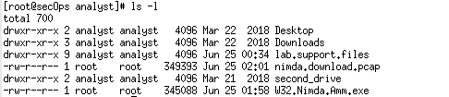

**Step 2: Tuning Firewall Rules Based on IDS Alerts**

a. In the CyberOps Workstation VM, start a third R1 terminal window.

**mininet > xterm R1**

b. In the new R1 terminal window, use the iptables command to list the chains and their rules currently in use:

**[root@secOps ~]# iptables -L -v**

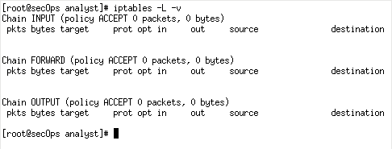

1. Connections to the malicious server generate packets that must transverse the iptables firewall on R1. Packets traversing the firewall are handled by the FORWARD rule and therefore, that is the chain that will receive the blocking rule. To keep user computers from connecting to the malicious server identified in Step 1, add the following rule to the FORWARD chain on R1:
2. Use the iptables command again to ensure the rule was added to the FORWARD chain. The CyberOps Workstation VM may take a few seconds to generate the output:

**[root@secOps ~]# iptables -I FORWARD -p tcp -d 209.165.202.133 --dport 6666 -j DROP**

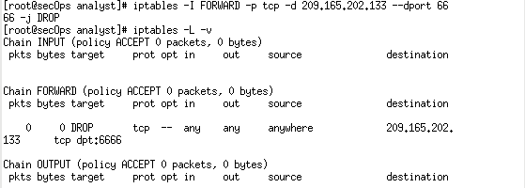

1. On H5, try to download the file again:

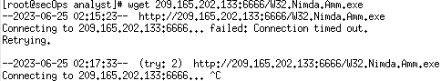

**Part 3: Terminate and Clear Mininet Process**

a. Navigate to the terminal used to start Mininet. Terminate the Mininet by entering quit in the main CyberOps VM terminal window.

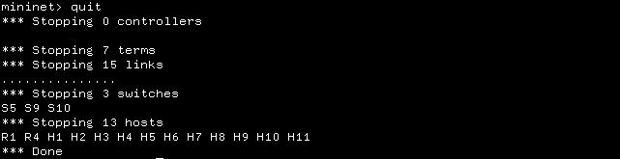

b. After quitting Mininet, clean up the processes started by Mininet. Enter the password cyberops when prompted.

**[analyst@secOps scripts]$ sudo mn –c**

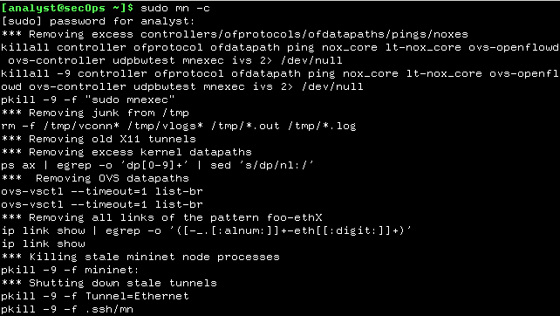

**Practical No.3**

**Aim: Demonstrate Extract an Executable from a PCAP.**

**Step 1:** open terminal and write this command **“cd ./lab.support.files/pcaps/ ”**

**Step 2**: write **“ls -l”** list command.

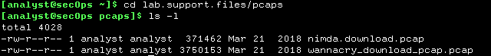

**Step 3:** On command promt **“ ”** (This will open the

wireshark UI)



**Step 4**: Check HTTP and check host and full URL to download the malware file.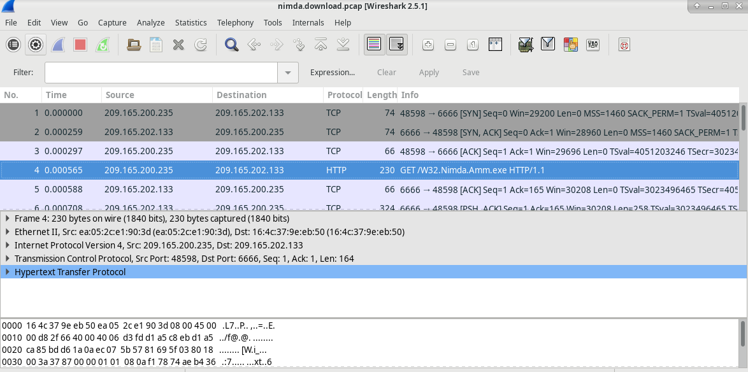

**Step 5:** right click on TCP which shows top on the list. Then click on Follow TCP

Stream.

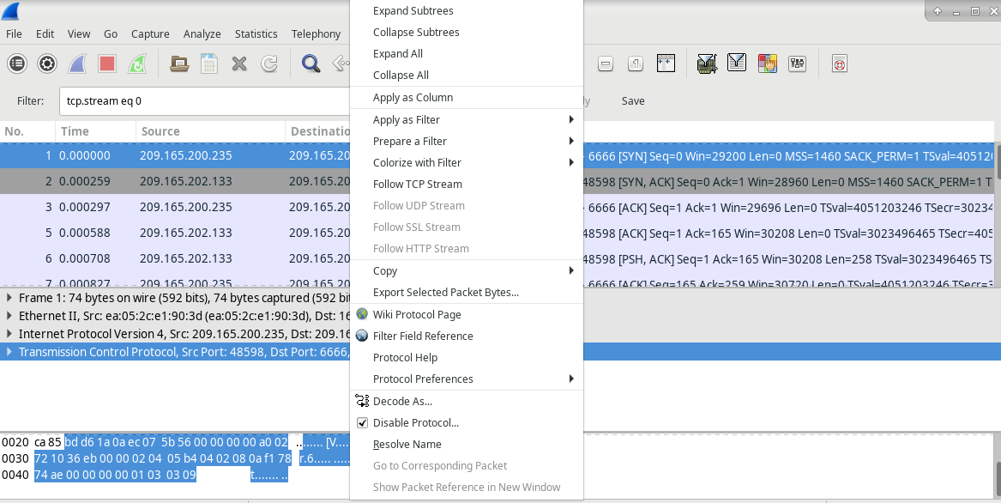

**Step 6:** Check the original file name in the Follow TCP Stream window.

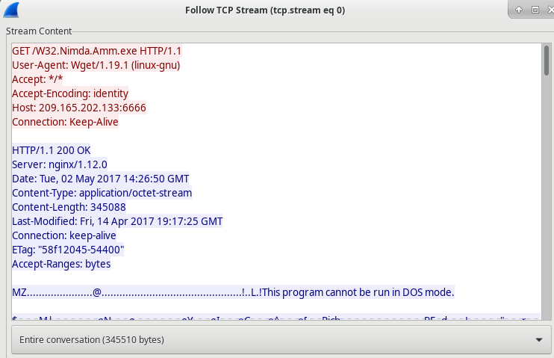

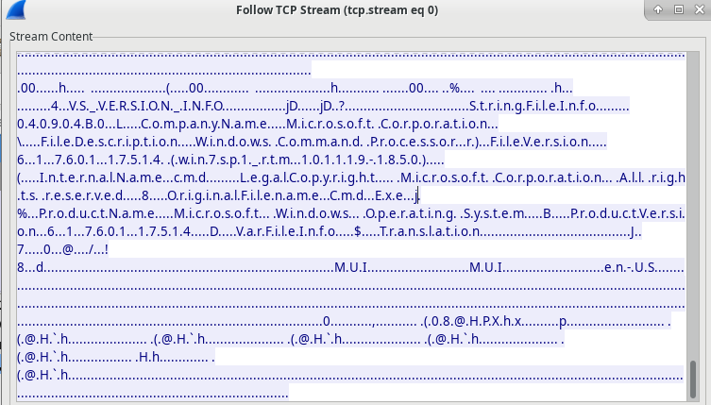

**Step 7:** Now we need to download and check that file by uploading to an online

virustotal website.

Find exe file from HTTP>click file> select export obj > Select exe File >Save as >

Select Folder> Save

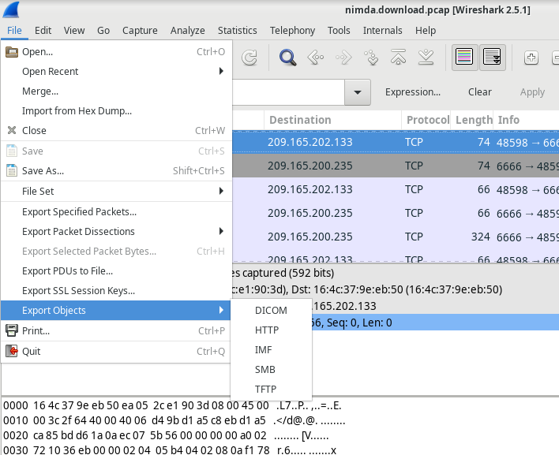

In the HTTP object list window, select the W32.Nimda.Amm.exe file and click Save As at the bottom of the screen.

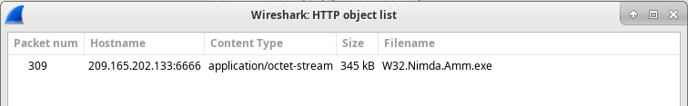

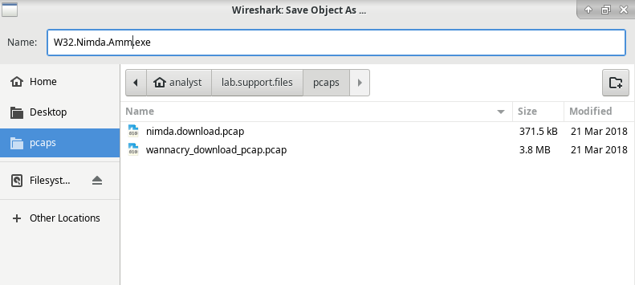

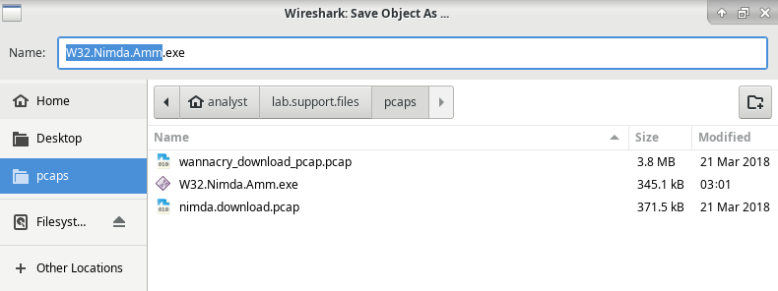

**Step 8:** In command prompt “**ls -l** “ to check if the file is saved or not.

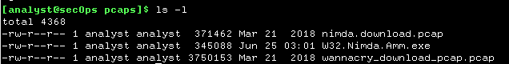\

**Step 9:** to check the file information put this command **“file W32.Nimda.Amm.exe”**



**Practical No.4**

**Aim: Demonstrate Analysis of DNS Traffic.**

**Part 1: Capture DNS Traffic**

**Part 2: Explore DNS Query Traffic**

**Part 3: Explore DNS Response Traffic**

**Solution:**

**Part 1: Capture DNS Traffic**

Step 1: Open **Wireshark** and start a Wireshark capture by double clicking a network interface with traffic.

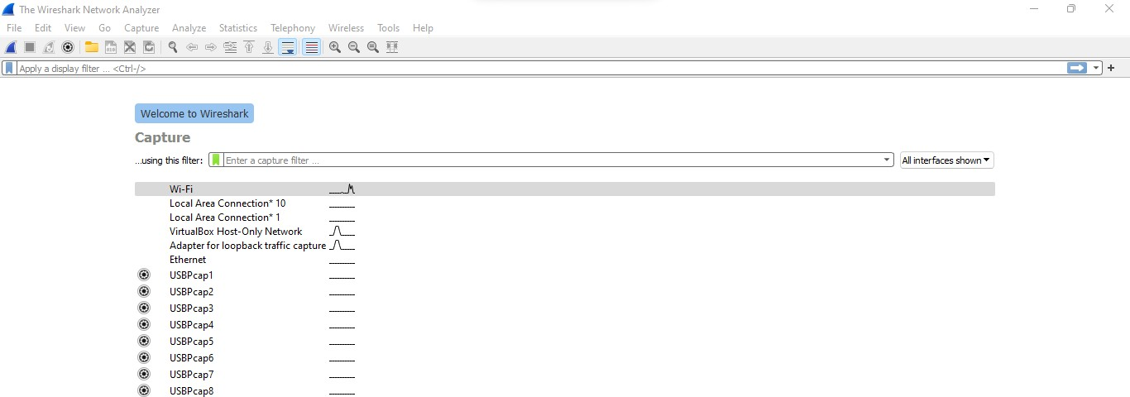

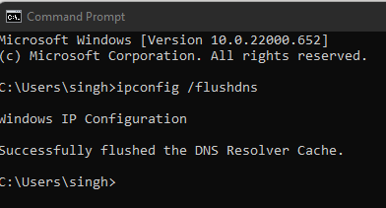Step 2: At the Command Prompt, enter **ipconfig /flushdns** clear the DNS cache.

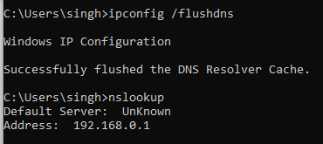Step 3: Enter **nslookup** at the prompt to enter the nslookup interactive mode.

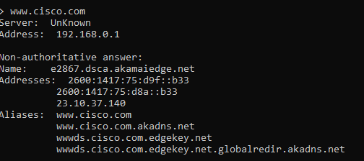Step 4: Enter the domain name of a website. The domain name [www.cisco.com](https://www.cisco.com/)

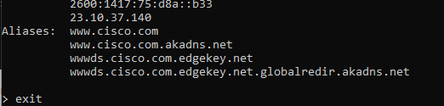Step 5: type **exit in prompt it will exit the nslookup**

# Part 2: Explore DNS Query Traffic.

Step 1: Observe the traffic captured in the Wireshark Packet List pane. Enter **udp.port == 53** in the filter box and click the arrow (or press enter) to display only DNS packets.

Select the DNS packet labeled **Standard query 0x0002 A** [**www.cisco.com**.In](http://www.cisco.com.In/) the Packet Details pane, notice this packet has Ethernet II, Internet Protocol Version 4, User Datagram Protocol and Domain Name System (query).

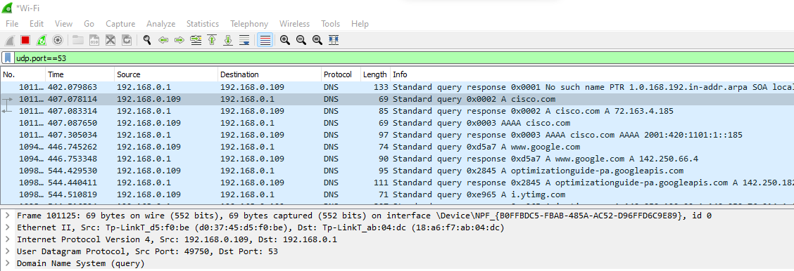

Expand **Ethernet II** to view the details. Observe the source and destination fields.

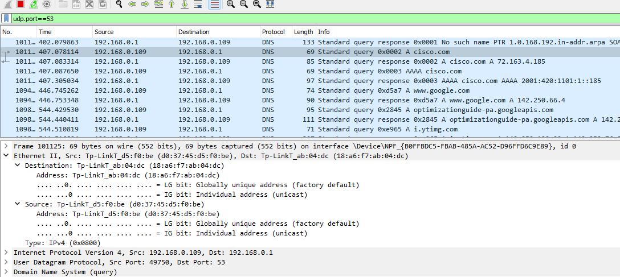

What are the source and destination MAC addresses? Which network interfaces are these MAC addresses associated with?

In this example, the source MAC address is associated with the NIC on the PC and the destination MAC address is associated with the default gateway. If there is a local DNS server, the destination MAC address would be the MAC address of the local DNS server.

Expand **Internet Protocol Version 4**. Observe the source and destination IPv4 addresses.

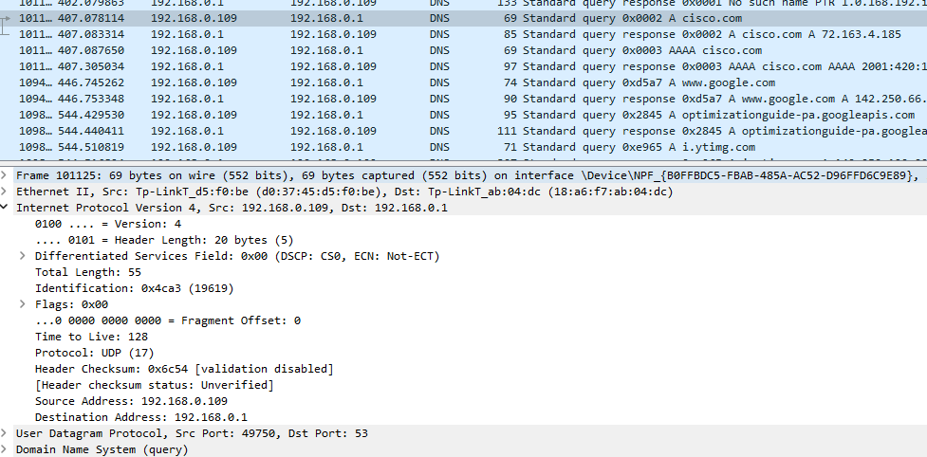

What are the source and destination IP addresses? Which network interfaces are these IP addresses associated with?

In this example, the source IP address is associated with the NIC on the PC and the destination IP address is associated with the DNS server.

Expand the **User Datagram Protocol**. Observe the source and destination ports.

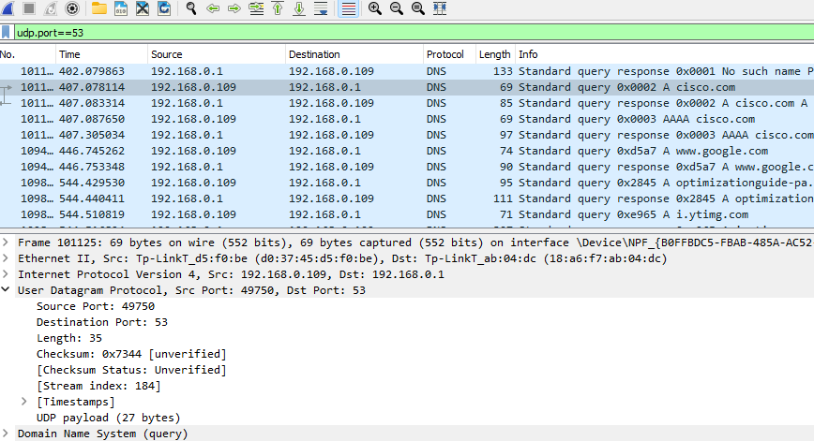

What are the source and destination ports? What is the default DNS port number?

The source port number is 58461 and the destination port is 53, which is the default DNS port number.

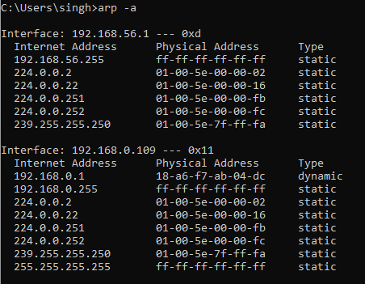Open a Command Prompt and enter **arp –a** and **ipconfig /all** to record the MAC and IP addresses of the PC

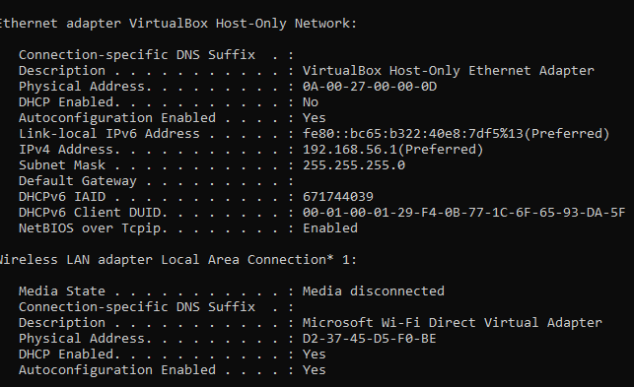

Compare the MAC and IP addresses in the Wireshark results to the results from the **ipconfig /all** results. What is your observation?

The IP and MAC addresses captured in the Wireshark results are the same as the addresses listed in arp – a and ipconfig /all command.

Expand **Domain Name System (query**) in the Packet Details pane. Then expand the **Flags** and **Queries**.

Observe the results. The flag is set to do the query recursively to query for the IP address to [www.cisco.com.](http://www.cisco.com/)

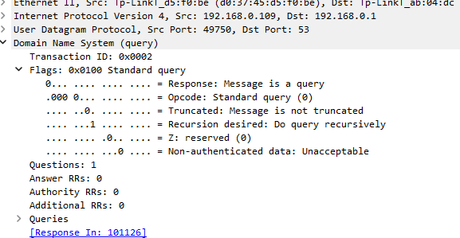

# Part 3: Explore DNS Response Traffic

Step 1: Select the corresponding response DNS packet labeled **Standard query response 0x0002 A** [**www.cisco.com**.](http://www.cisco.com/)

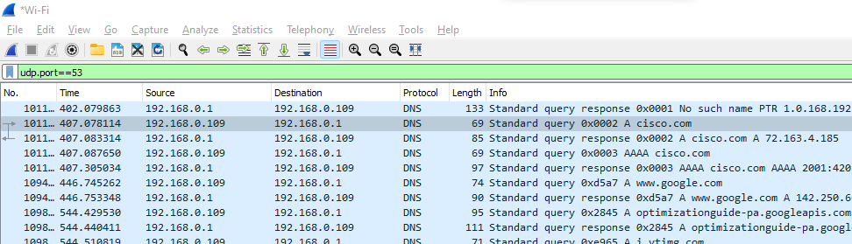

Step 2: Expand **Domain Name System (response)**. Then expand the **Flags**, **Queries**, and **Answers**. Observe the results.

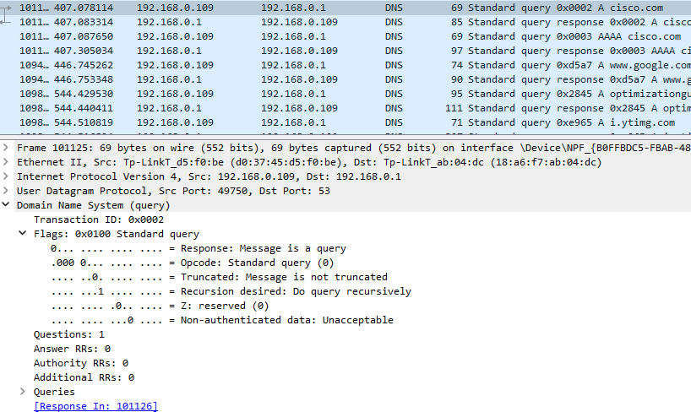

**Practical No 5**

**Aim: Create your own syslog Server**

Step 1: To check whether rsyslog services already running or not use above command

“sudo systemctl status rsyslog”

Step 2: In case not installed or running, install rsyslog using the following commands:

# “sudo apt-get update”

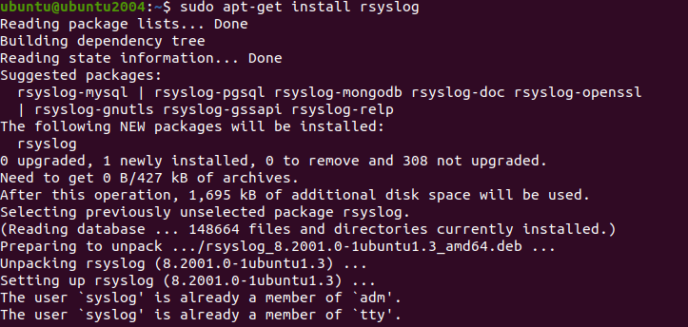**“sudo apt-get install rsyslog”**

Step 3: Open rsyslog configuration file

# “sudo nano /etc/rsyslog.conf”

Step 4: Uncomment above four lines that enable udp and tcp port binding:

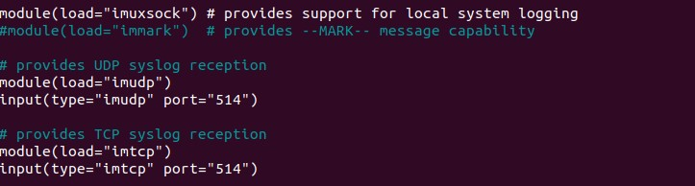

Step 5: Add template right before GLOBAL DIRECTIVES section.

# $template remote-incoming- logs,"/var/log/%HOSTNAME%/%PROGRAMNAME%.log"

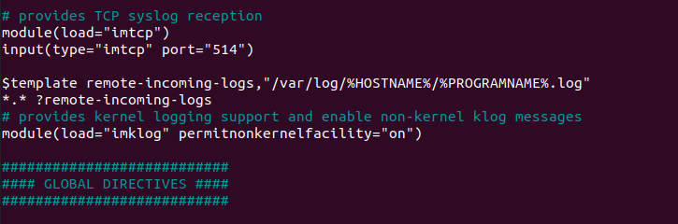**\*.* ?remote-incoming-logs**

Step 6: Save and restart rsyslog service:

# “sudo systemctl restart rsyslog”

Step 7: Confirme that rsyslog service is listening on configured ports

# “ss -tunelp | grep 514”

Step 8: Allow rsyslog firewall port rules

# “sudo ufw allow 514/tcp” “sudo ufw allow 514/udp”

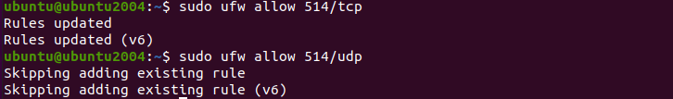

Step 9: To verify configuration, run the following command:

# “sudo rsyslogd -N1 -f /etc/rsyslog.con

**Practical No.6**

**Aim: Configure your Linux system to send syslog messages to a syslog server and Read them.**

Step 1: Install and configure rsyslog server first for that please refer practical no 5.

Step 2: Open kali linux and install rsyslog using the following commands

**“sudo apt-get update”**

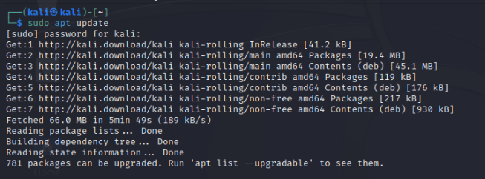

**“sudo apt-get install rsyslog”**

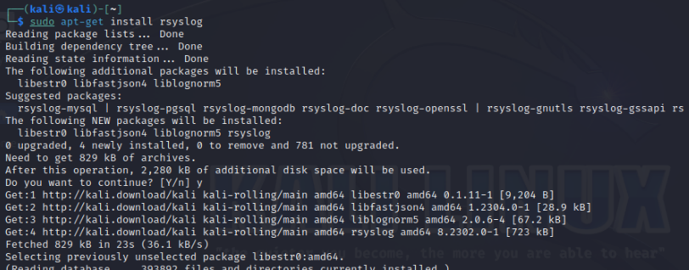

Step 3: Open rsyslog configuration file

**“sudo nano /etc/rsyslog.conf”**

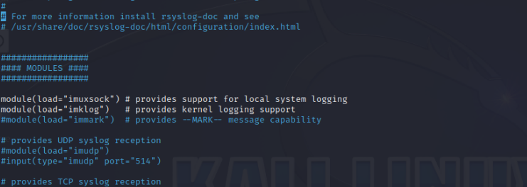

Step 4: Add above lines at the end of the file

**@192.168.137.50:514**

**\*.* @@192.168.137.50:514**

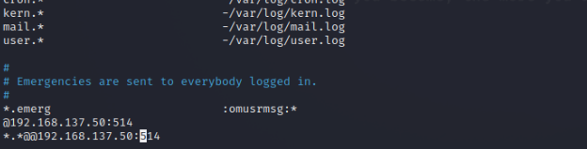

Note: You can enable to send logs over UDP. For TCP use @@ , instead of one

Step 5: For the end add these following variables in case when the rsyslog server goes

down.

**$ActionQueueFileName queue**

**$ActionQueueMaxDiskSpace 1g**

**$ActionQueueSaveOnShutdown on**

**$ActionQueueType LinkedList**

**$ActionResumeRetryCount -1**

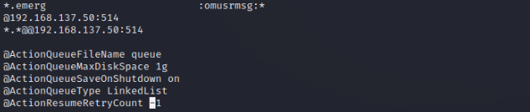

Step 6: Then Save and exit the file

Step 7: restart the rsyslog service

**“sudo systemctl restart rsyslog”**



**Verify the logs**

After the configuration is completed on the client machine, we want to verify that

everything went well.

Step 8: Go to your Rsyslog server to verify the logs from your client machine

**“ls /var/log/”**

In my case, the directory named kali is the name of my client machine which I am

currently using. We will enter this directory and see something like this:

Step 9: To check logs use the following command: Let's for example inspect

rsyslogd.log.

**“sudo tail -f /var/log/kali/rsyslogd.log”**

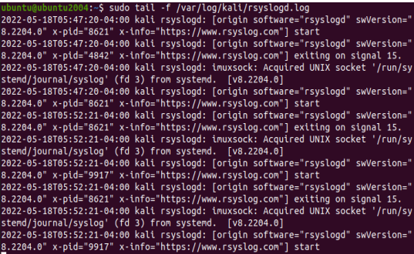

**Practical No.7**

**Aim: Install and Run Splunk on Linux.**

Step1: Download Splunk Installer

**“cd /tmp && wget**

**https://download.splunk.com/products/splunk/releases/7.1.1/linux/splunk-7.1.1-**

**8f0ead9ec3db-linux-2.6-amd64.deb”**

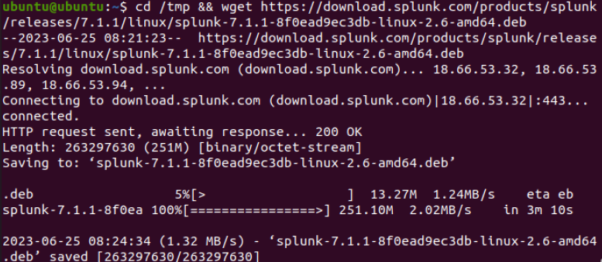

Step 2: Install Splunk

**“sudo dpkg -i splunk-7.1.1-8f0ead9ec3db-linux-2.6-amd64.deb”**

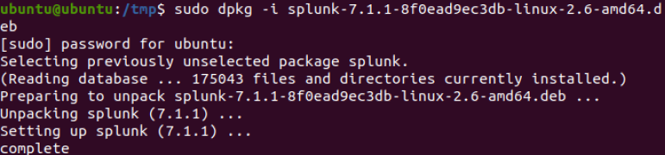

Step 3: Enable the Splunk to start at boot

Press enter key till you reach to the end of the agreement, then you have to

accept the license agreement by typing “y”.

Then you have to enter the initial admin password and use this password to

access the web portal

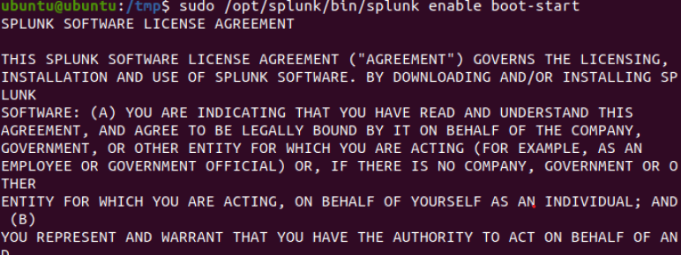



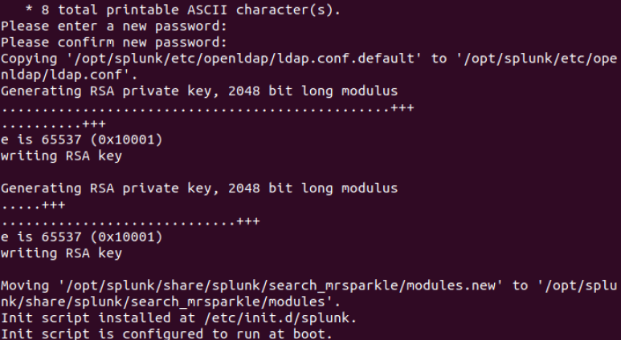

Step 4: Start the Splunk service

**“sudo service splunk start”**



Step 5: Check splunk service Status

**“sudo service splunk status”**

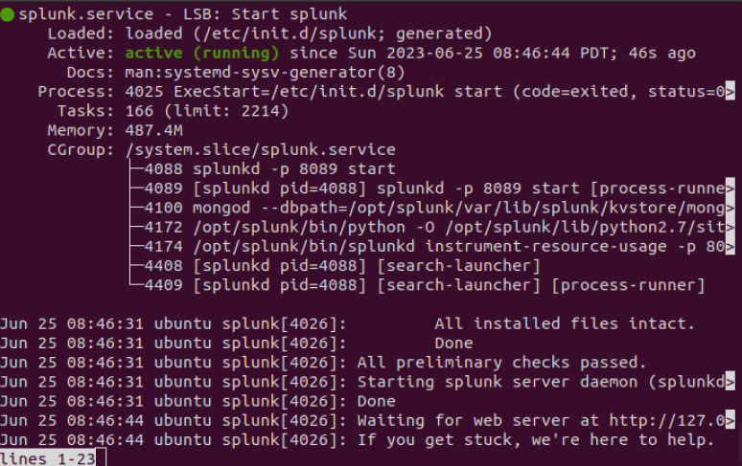

Step 6: Splunk will be started at port 8000. You can access the application via URL

“http://localhost:8000/“. To logged in into the app enter username as “admin” then

enter your password. In my case the password is “admin!123”

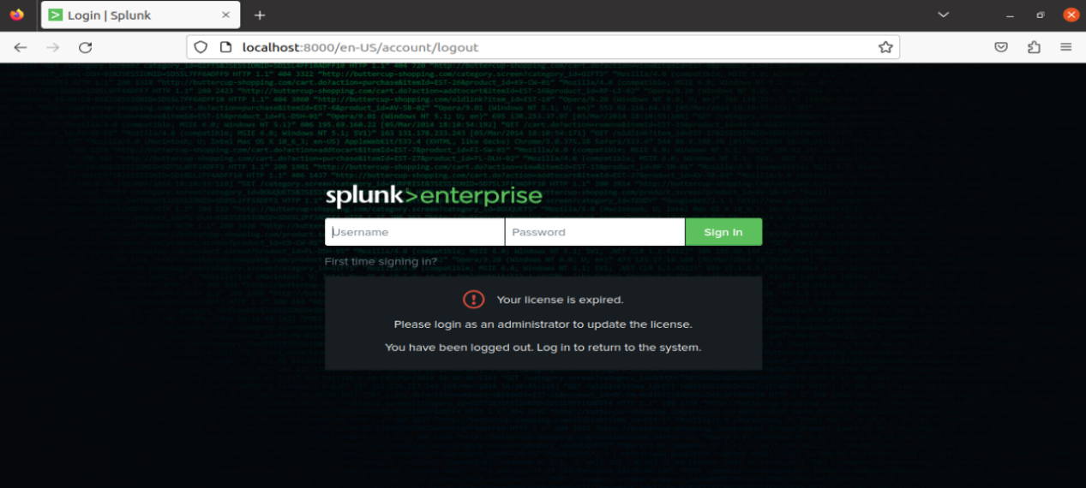

Step 7: After you logged in into the app you can see the above screen

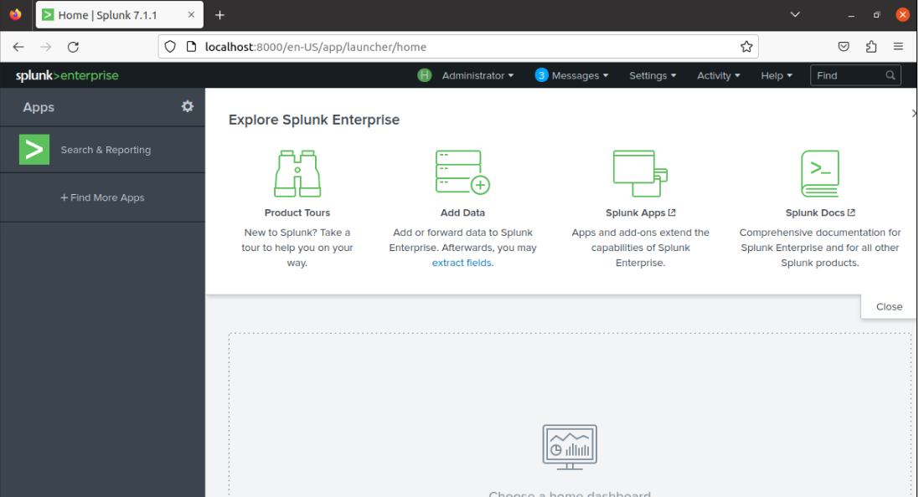

**Practical No.8**

**Aim: Install and Configure ELK on Linux.**

**Part 1: Installing java**

Step 1: write the below command and update and install the jdk

**“sudo apt update”**

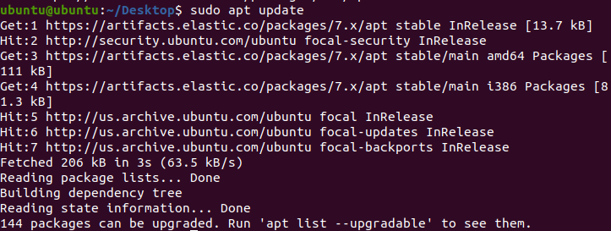

**Install java**

**“sudo apt install default-jre”**

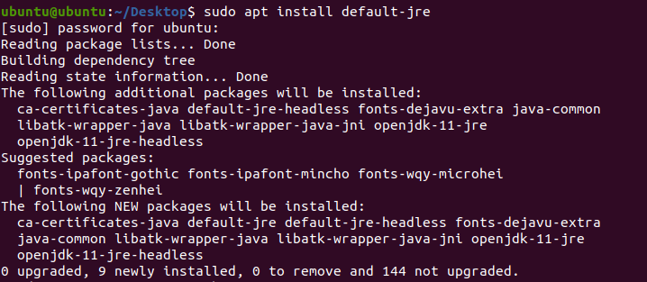

Step 2: check the java version by this command “java -version”

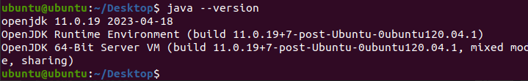

**Part 2: Install and Configure the Elasticsearch**

**Elastic Search**

Elasticsearch store logs coming from external sources and offers real-time distributed search and analytics with the RESTful web interface.

Step 1: Download and install the GPG signing key.

**“curl -fsSL https://artifacts.elastic.co/GPG-KEY-elasticsearch | sudo apt-key add -”**



Step 2: Set up the Elasticsearch repository on your system by running the below

command.

**“echo "deb https://artifacts.elastic.co/packages/7.x/apt stable main" | sudo tee -a /etc/apt/sources.list.d/elastic-7.x.list”**



Step 3: Update the repository cache and then install the Elasticsearch package.

**“sudo apt update”**



**“sudo apt install elasticsearch”**

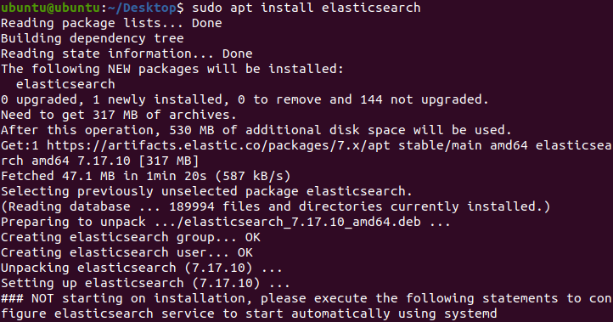

Step 4: Edit the Elasticsearch configuration file to set the cluster name for Graylog set

up.

**“sudo nano /etc/elasticsearch/elasticsearch.yml”**

**Uncomment**

**network.host:localhost**

**http.port:9200**

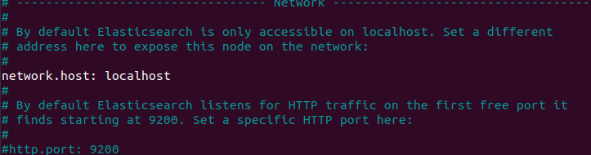

Step 5: Next, start the Elasticsearch service with the systemctl. Give Elasticsearch little time to start up otherwise, you can get errors about not being able to connect to it.

**sudo systemctl start elasticsearch**

Step 6: Now, run the below command. It will enable Elasticsearch to start every time your server boots:

**sudo systemctl enable elasticsearch**

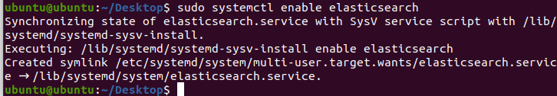

Step 7: You will then test whether your Elasticsearch service is running. Do it by sending an HTTP request:

**curl -X GET "localhost:9200"**

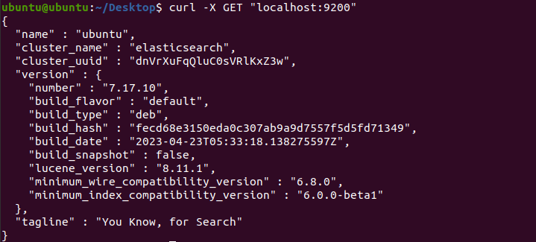

**Practical No: 9**

**Aim: Install and Configure GrayLog on Linux**

**Part 1: Install Java and Els**

Step 1:Install Java and Els (Practical 8)

Step 2: Edit the Elasticsearch configuration file to set the cluster name for Graylog set

up.

**“sudo nano /etc/elasticsearch/elasticsearch.yml”**

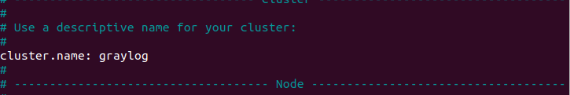

Step 3: Set the cluster name as graylog, as shown below. Then, uncomment the line and

below add this line **“action.auto_create_index: false”** then save.

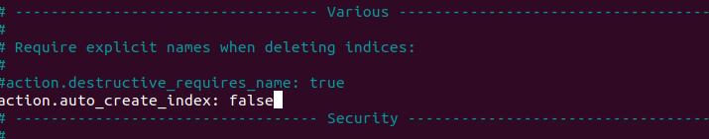

Step 4: Start the Elasticsearch service to read the new configurations.

**“sudo systemctl daemon-reload”**

**“sudo systemctl start elasticsearch”**

**“sudo systemctl enable elasticsearch”**

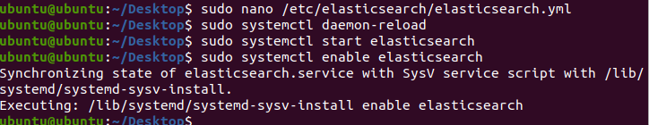

Step 5: Elastic search should be now listening on port 9200. Use the curl command to

check the Elasticsearch’s response

**“curl -X GET http://localhost:9200 ”**

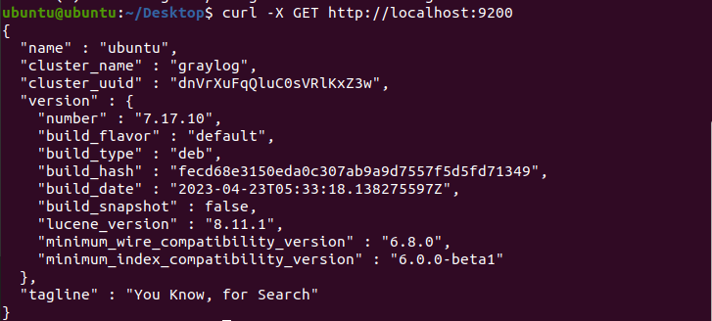

**Part 2: Install MongoDB**

MongoDB acts as a database for storing Graylog’s configuration. Graylog requires MongoDB v3.6, 4.0 or 4.2. Unfortunately, MongoDB's official repository doesn’t have the required MongoDB

versions for Ubuntu 20.04. So, we will install MongoDB v3.6 from the Ubuntu base repository.

**Step 1: “sudo apt update”**

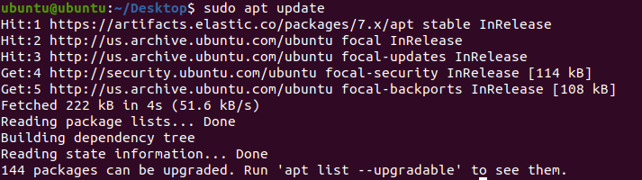

**“sudo apt install -y mongodb-server”**

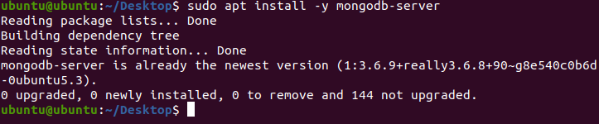

Step 2: Start the MongoDB and enable it on the system start-up.

**“sudo systemctl start mongodb”**

**“sudo systemctl enable mongodb”**

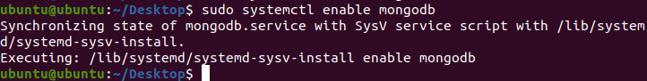

**Part 4: Install GrayLog Server**

GrayLog Server reads data from Elasticsearch for

search queries comes from users and then displays it for them through the Graylog web

interface.

Step 1: Download and install the Graylog 3.3 repository configuration package.

**“wget https://packages.graylog2.org/repo/packages/graylog-4.2-**

**repository_latest.deb”**

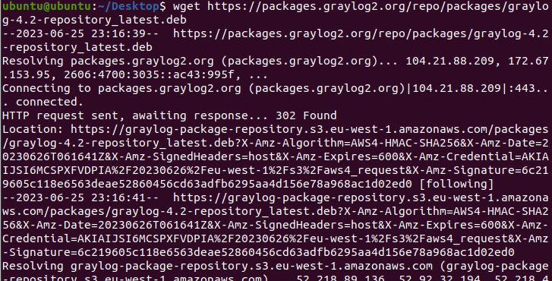

**“sudo dpkg -i graylog-3.3-repository_latest.deb”**

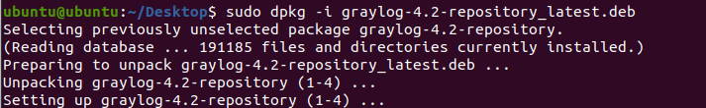

Step 2: Update the repository cache. **“sudo apt update”**

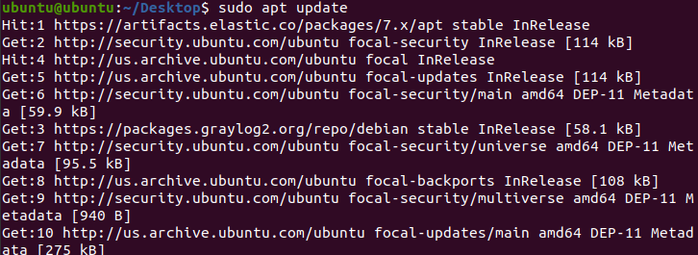

Step 3: Install the Graylog server using the following command.

**“sudo apt install -y graylog-server”**

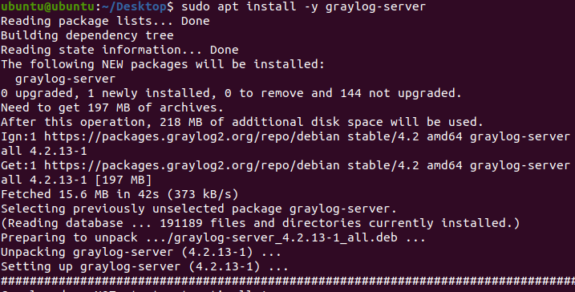

Step 4: You must set a secret to secure the user passwords. Use the pwgen command to

generate the secret.

**“pwgen -N 1 -s 96”**

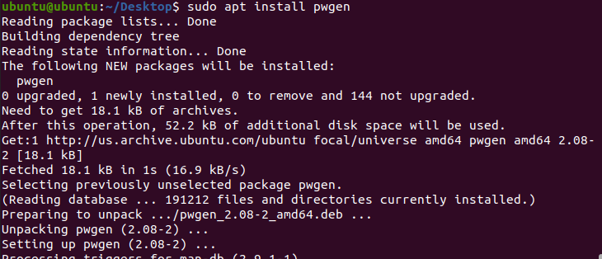



Step 5: **sudo gedit /etc/graylog/server/server.**conf edit the conf file and put

Then, place the secret like below.

**sudo nano /etc/graylog/server/server.conf**

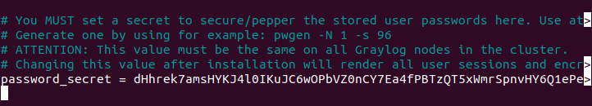

Step 6: Now, generate a hash (sha256) password for the root user (not to be confused

with the system user, the root user of graylog is admin).

You will need this password to login to the Graylog web interface. Admin’s password

can’t be changed using the web interface. So, you must edit this variable to set.

Replace password with the choice of your password. Put this command in terminal

**“echo -n password | sha256sum”**



Step 7: Edit the server.conf file again.in terminal

**“sudo nano /etc/graylog/server/server.conf”**

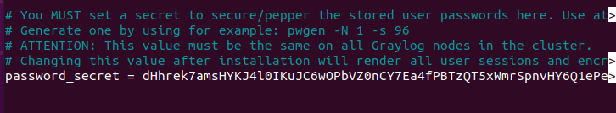

**Part 5: Setup Graylog web interface**

From version Graylog 2.x, the web interface is being served directly by the Graylog

server. Step 1: Enable the Graylog web interface by editing the server.conf file.

**“sudo gedit /etc/graylog/server/server.conf”**

**Put http_bind_address = 192.168.0.10:9000**

**http_external_uri = http://public_ip:9000/**

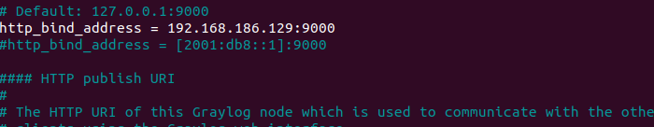

Step 2: Start and enable the Graylog service.

Place the below command

**“sudo systemctl daemon-reload”**

**“sudo systemctl start graylog-server”**

**“sudo systemctl enable graylog-server”**

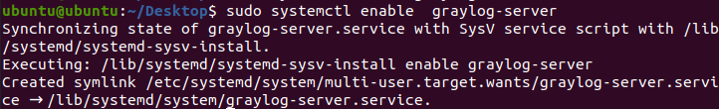

**Step 3:** Keep looking Graylog server startup logs. This log will be useful for you to

troubleshoot Graylog in case of any issues.

**“sudo tail -f /var/log/graylog-server/server.log”**

**Step 4:** On the successful start of the Graylog server, you should get the following

message in the log file.

You will able to see the log file**.**

**2020-08-03T16:03:06.326-04:00 INFO [ServerBootstrap] Graylog server up and**

**running.**

**Access Graylog**

The Graylog web interface will now be listening on port 9000. Open your browser and

point it to.

**“http://ip.add.re.ss:9000” type in browser.**

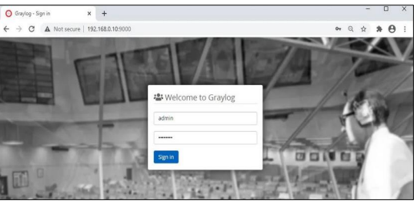

**Practical No.10**

**Aim: Demonstrate Conversion of Data into a Universal Format.**

**Part 1: Normalize Timestamps in a Log Files.**

Step 1: Launch the CyberOps Workstation VM.

Step 2: open terminal and type **“cd /home/analyst/lab.support.files/”**

Then type **“ls –l”**

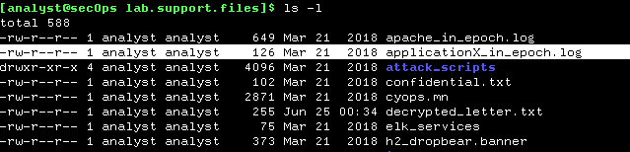

Step 3: Issue the following AWK command to convert and print the result on the

terminal:

Write the command

**“awk 'BEGIN {FS=OFS="|"} {$3=strftime("%c",$3)} {print}' applicationX_in_epoch.log”**

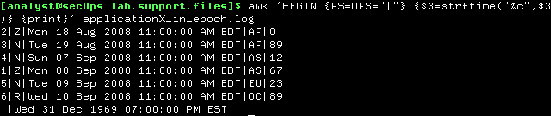

The command above is an AWK script. It may seem complicated. The main structure of the AWK script above is as follows:

**▪ awk –** This invokes the AWK interpreter.

**▪ „BEGIN –** This defines the beginning of the script.

**▪ {} –** This defines actions to be taken in each line of the input text file. An AWK script can have several actions.

**▪ FS = OFS = “|” –** This defines the field separator (i.e., delimiter) as the bar (|) symbol. Different text files may use different delimiting characters to separate fields.This operator allows the user to define what character is used as the field separator in the current text file.

▪ **$3** – This refers to the value in the third column of the current line. In the applicationX_in_epoch.log, the third column contains the timestamp in epoch to be converted.

▪ **strftime** – This is an AWK internal function designed to work with time. The %c and $3 in between parenthesis are the parameters passed to strftime.

▪ **applicationX**_in_epoch.log – This is the input text file to be loaded and used.

Because you are already in the lab.support.files directory, you do not need to add path information, /home/analyst/lab.support.files/applicationX_in_epoch.log.

Step 4: Use nano (or your favorite text editor) to remove the extra empty line at the end of the file

**[analyst@secOps lab.support.files]$ nano applicationX_in_epoch.log**

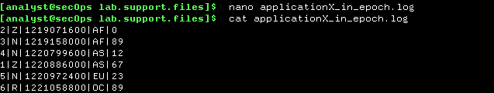

Step 5:While printing the result on the screen is useful for troubleshooting the script, analysts will likely need to save the output in a text file. Redirect the output of the script above to a file named applicationX_in_human.log to save it to a file:

**[analyst@secOps lab.support.files]$ awk 'BEGIN {FS=OFS="|"} {$3=strftime("%c",$3)} {print}' applicationX_in_epoch.log > applicationX_in_human.log**

Use cat to view the **applicationX_in_human.log.** Notice that the extra line is now removed and the timestamps for the log entries have been converted to human readable format.

**[analyst@secOps lab.support.files]$ cat applicationX_in_human.log**

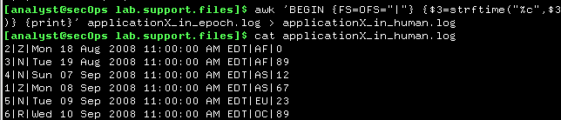

**Part 2: Normalize Timestamps in an Apache Log File**

Similar to what was done with the applicationX_in_epoch.log file, Apache web server

log files can also be normalized.

Step 1: Open the terminal and type cat apache_in_epoch.log.

**[analyst@secOps lab.support.files]$ cat apache_in_epoch.log**

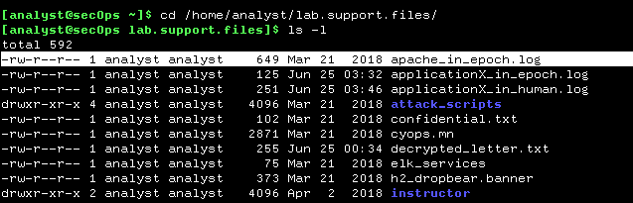

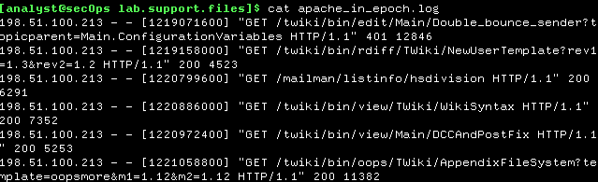

Step 2: In the CyberOps Workstation VM terminal, a copy of the Apache log file,

apache_in_epoch.log, is stored in the /home/analyst/lab.support.files.

Step 3: type this command in the terminal to see the log in human readable.

**[analyst@secOps lab.support.files]$ awk 'BEGIN {FS=OFS=" "} {$4=strftime("%c",$4)} {print}' apache_in_epoch.log**

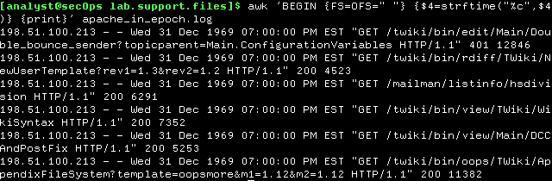

Step 4: Before moving forward, think about the output of the script.

Can you guess what caused the incorrect output? Is the script incorrect? What are the relevant differences between the **applicationX_in_epoch.log and**  **apache_in_epoch.log?**

The problem is the square brackets in the course file. The script expects the timestamp to be in the Unix Epoch format which does not include the square brackets. Because the script does not know what number represents the “[“ character, it assumes zero and returns the Unix beginning of time in UTC -5.

Step 5: To fix the problem, the square brackets must be removed from the timestamp field before the conversion takes place. Adjust the script by adding two actions before the conversion. As shown,

**[analyst@secOps lab.support.files]$ awk 'BEGIN {FS=OFS=" "} {gsub(/[|]/,"",$4)}{print}{$4=strftime("%c",$4)}{print}' apache_in_epoch.log**

